# Lab 6

## Assigning IP Address to a Network (Statically, using Command)

1. Make a network similar to this and open the Router settings.

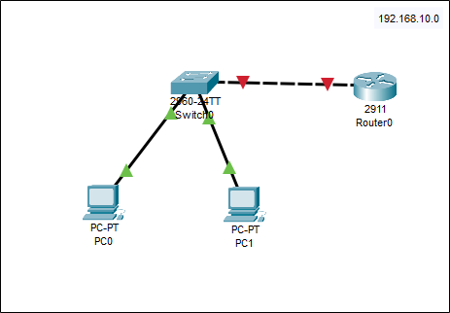

1. Open CLI

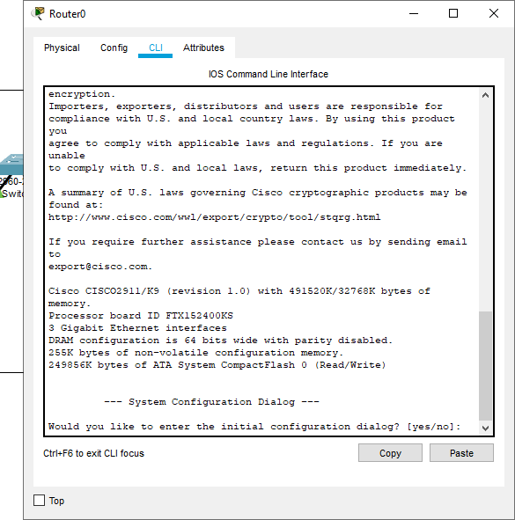

1. If it asks for “yes/no” type no and press **enter** twice.

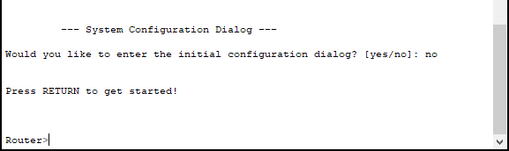

1. When it says “**Router>**” type “**enable**” to change it to “**Router#**”



1. Next, type “**config**” or “**configure**” or “**configure terminal**” and press enter twice.

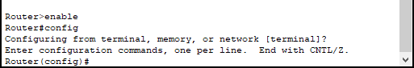

1. Now type the command “interface name”, like “**interface gig0/1**”, gig0/1 is the port of router which is connected to the network.

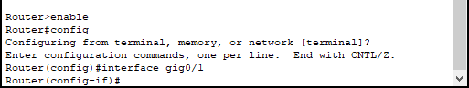

1. When it says “config-if” it means, it is in its “interface” now. Next command is to configure IP. Type: “ip address ipaddress subnetmask” like “**ip address 192.168.10.1 255.255.255.0**” for this network.

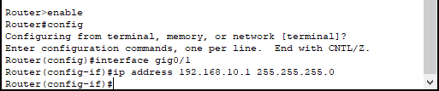

1. After this, to turn-on the port/service, type “**no shutdown**”, press **enter** and then type “**end**” and press **enter** to go back to initial “**Router#**”

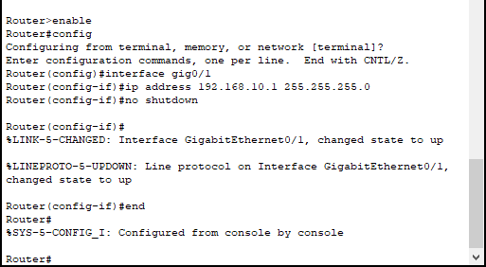

1. Close the Router settings, and hover over the router to double check if the IP is configured or not.

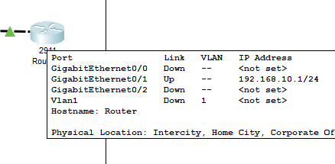

1. Now, statically configure IP addresses from this Network, like we did in “Lab-3” and afterwards hover over the PCs to check if the IP is configured or not

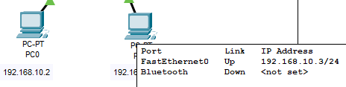

1. Open any of the PC setting and go to “Command Prompt”, type “ping IP_Address_of_other_Pc” like “**ping 192.168.10.3**” to check if there’s communicating between two PCs

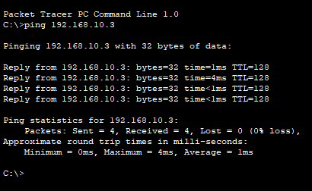

1. Similarly, type “telnet IP_Address_of_Router” like “**telnet 192.168.10.1**” to check the connection with router.



**Task 1;**

# Lab 6 - Task

### Design network of "Lab-7" or “Lab-8” (2-3 rows of computers) Use:

* Switch (1)

### Router (1)

* End-Devices like Laptop/PC

### Assign IP Address (167.158.15.0) using Command for Router. And Statically for End-Devices

### 

### 